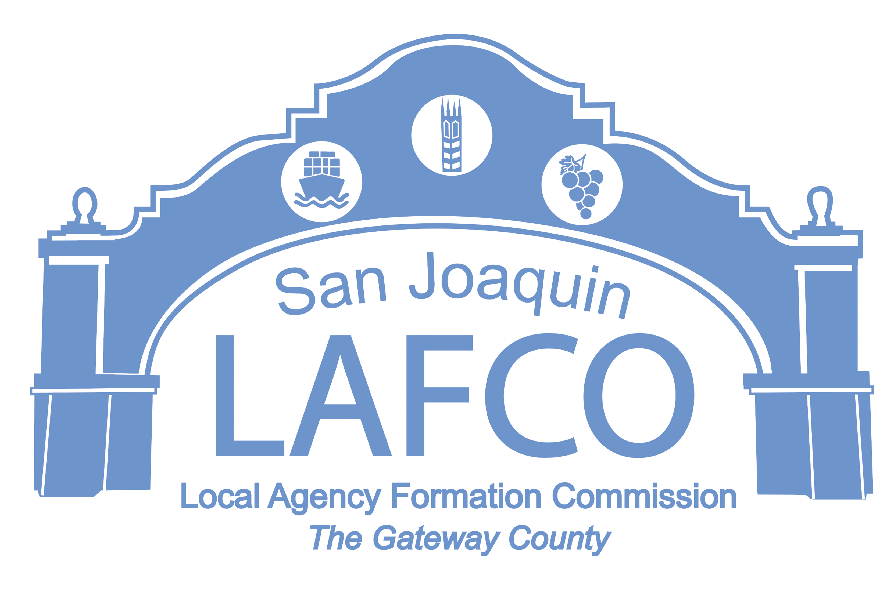
Balancing Community and Commerce
44 N. SAN JOAQUIN STREET SUITE 374 STOCKTON, CA 95202 209-468-3198

* * * *

THE SAN JOAQUIN LOCAL

AGENCY FORMATION

COMMISSION (LAFCo)

MEETING SCHEDULED FOR

AUGUST 10, 2023

HAS BEEN
CANCELLED

