Balancing Community and Commerce
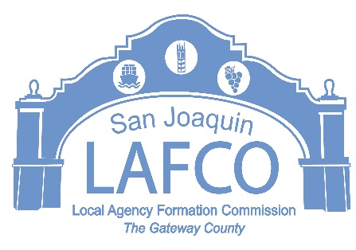
5000 S. AIRPORT WAY SUITE 209 STOCKTON, CA 95206 209-953-7646

NOTICE OF PUBLIC HEARING
LOCAL AGENCY FORMATION COMMISSION
FINAL BUDGET FOR FISCAL YEAR 2026-2027, WORK PROGRAM AND PROPOSED SCHEDULE OF FEES

NOTICE IS HEREBY GIVEN that on Thursday, June 11, 2026 at 9:00 A.M. in the Chambers of the Board of Supervisors, 6th floor, 44 N. San Joaquin Street, Stockton, CA, the San Joaquin Local Agency Formation Commission will conduct a public hearing to consider the adoption of the Final Budget for the Fiscal Year 2026-2027, Work Program and Schedule of Fees.

Details of the proposed budget and fee schedule are available by contacting the LAFCo Office at 209-953-7646 during regular business hours or online at www.sjlafco.org Written comments may be submitted to the LAFCo Office located at 5000 S. Airport Way, Suite #209, Stockton, Ca 95206

All interested persons may appear at said hearing and present their views on any matter relating to the proposal at that time. If you have any questions or need more information, please call and leave a voice message on the LAFCo business phone at (209) 953-7646, or email the Executive Officer at jhightower@sjgov.org

BY ORDER OF THE SAN JOAQUIN
LOCAL AGENCY FORMATION COMMISSION
Dated: May 21, 2026 J.D. HIGHTOWER, Executive Officer

